Non-functional Card
Estimated time : ~ 20 min

“Ok, so far we were talking about functionalities of your system. Now we will move on and start discussing important non-functional aspects of <product-name> .
Here is a list *LFill.0* that we can use together to identify the most important quality attributes of your product.
We’d recall you that we are interested only in what was important in the first release of the product. ”

*Guide him suggesting some quality concern for his specific case*

Q.2.0 : “For example : You have a <something> in place ... I guess that in this case, is important to <some-important-nonFunctional-stuff> . Am I right?”

*Start a discussion together, leading the discussion aiming to write on the whiteboard the top non-functional aspects. Every time a NEW quality comes out ask him*

Q.2.1 : Why was this important?

For each attribute on the whiteboard
Q.2.2 : How did you realize it?

*PAUSE* Ask if everything is good....

Possible Answers

  - What do you mean by quality?

Non-technical answer : In general, quality is a set of properties of a product (or a service) that allow it to satisfy explicit or implicit needs.

Technical answer : “Quality attributes are the overall factors that affect run-time behavior, system design, and user experience. They represent areas of concern that have the potential for application wide impact across layers and tiers. Some of these attributes are related to the overall system design, while others are specific to run time, design time, or user centric issues.”

IEEE 729/1983
1.Quality as a feature (conformance to specifications)
2. Quality as a value (fitness for use)

Hints

Known tradeoffs:
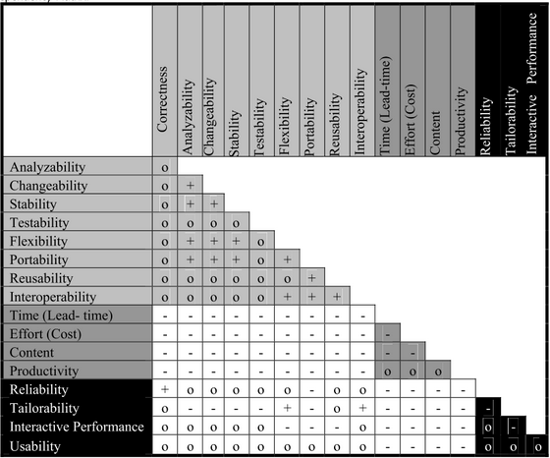

Standards:
ISO 9126: Functionality, reliability, usability, efficiency, maintainability and portability.
IEEE 1061: Efficiency, functionality, maintainability, portability, reliability and usability.
